Telecommuting, Professional Isolation, and Employee Development in Public and Private Organizations
Cecily D. Cooper and Nancy B. Kurland
Journal of Organizational Behavior , Vol. 23, No. 4, Special Issue: Brave New Workplace: Organizational Behavior in the Electronic Age (Jun., 2002), pp. 511-532
Published by: Wiley
Article Stable URL: http://www.jstor.org/stable/4093819

This research journal systematically documents the isolating effects of telecommuting. These researchers from university of southern California interview 93 public and privet sector employees and their supervisors and record their responses. The chosen organizations (2 city government and 2 tech companies) provided friendly atmospheres for telecommuting. This is important to demonstrate the challenges of offsite work even when the supervisors are helpful and accommodating. I aim use this research to establish professional isolation as a problematic side effect of telecommuting.

Our basic finding is that both public and private employees perceive that professional isolation is inextricably linked to employee development activities. Employee development involves employee learning and overall skill growth. It differs from training in that development is not necessarily related to specific requirements of a present or future job (Nadler & Nadler, 1990). Professional isolation, by definition, occurs when telecommuters, because they are off-site and out-of-sight, miss important organizational rewards. More specifically, we found that telecommuters miss three types of develop-mental activities that occur frequently in a conventional workplace: (1) interpersonal networking with others in the organization; (2) informal learning that enhances work-related skills and information distribution;a nd (3) mentoringf rom colleagues and superiors.B y workingo ff-site for at least a portion of the work-week, telecommuters in the present study perceived that they did not have the same degree of access to these informal development opportunities.

Page 519

The Role of Relationships in Understanding Telecommuter Satisfaction
Timothy D. Golden
Journal of Organizational Behavior , Vol. 27, No. 3 (May, 2006), pp. 319-340
Published by: Wiley
Article Stable URL: http://www.jstor.org/stable/4093931

This research was conducted in Rensselaer Polytechnic Institute, NY on 294 telecommuting employees. Dr. Golden is focused on importance of long established methods of in person communication. Cooperating and learning by watching are built on these relationships. In contrast telecommuting is still a new system. The conveniences that benefit the workers and cost savings that benefit the employers are measure against the difficulties of long distance communication in this study. Dr. Golden’s study demonstrates that telecommuting for an extended period of time erodes the worker satisfaction.
.
Because of the changed work location, telecommuters rely on different forms of communication media to establish and maintain relationships. In some instances, when face-to-face interactions are replaced with electronic communication such as email and telephone, information during the exchanges is restricted. Information richness theory (Daft & Lengel, 1984, 1986; Lengel & Daft, 1988; Rice, 1993; Rice & Shook, 1990) suggests that the enactment of relationships that take place while telecommuting may be altered compared to a typical office exchange, since technology-enabled media contains less informational cues through which to fully interpret the interaction. For instance, while email may offer the telecommuter time flexibility to respond to requests whenever he or she is able, this lean medium often lacks complete information. Absent are a host of contextual indicators, back channel cues, and otheri nformationu seful for fully interpretingt he interaction.M oreover,w hile email may offer specificity when employees take time to carefully type and craft interactions with others, this is often unlikely in the rushed business context and such interactions lack synchronicity and spontaneity which are often useful for interpreting interactions.

Page 321

Video
http://www.youtube.com/watch?v=qB-N6c4hZWg
Anne Wend
Chris Eley
Sarah Hewing
Eastern Illinois University school of Technology

10.45
13.50
Remote Isolation
Angela Daniels
http://www.youtube.com/watch?v=maqhrtnYx1A
This short video compares an isolated non-productive telecommuter’s routine with that of a productive and socially engaged conventional worker. The conventional worker is able to brainstorm with co workers, socialize at lunch and solicit direct help on a project. The isolated telecommuter is continually distracted, and at the end of the day stares at a long list of overdue projects. It does not offer any suggestions or solutions, but since it was posted by someone who conducts most her work from home I chose it as a neutral demonstration vehicle.

cnn
http://articles.cnn.com/2007-09-27/living/cb.work.home.pitfalls_1_telecommuting-work-area-social-interaction?_s=PM:LIVING
describing the problem
"Some telecommuters find they miss the social aspects of working with other people."

The American Society of Training and Development 1998
An Organizational Guide to Telecommuting: Setting up and running a successful telecommuter program

George M. Piskurich
25 -
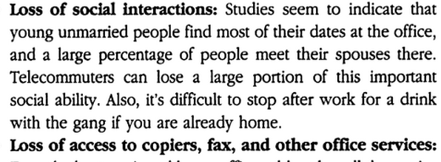
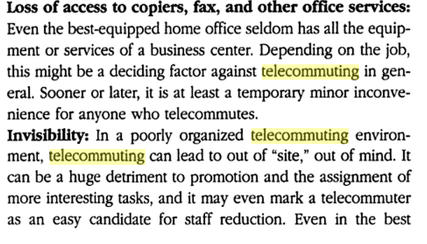
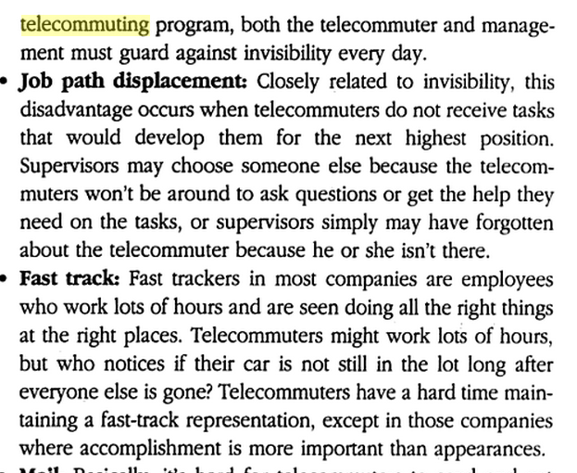
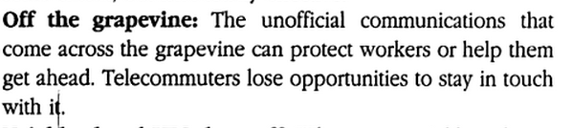

101 tips for telecommuters
101 tips for telecommuters
Debra A. Dinnocenzo
page: 56
"schedule face-to-face meetings with co-workers ... on a regular basis."
San Francisco - Berret-Koehler Publishers, Inc.

Debra A. Dinnocenzo
Berrett-Koehhler Publishers, Inc. 1999
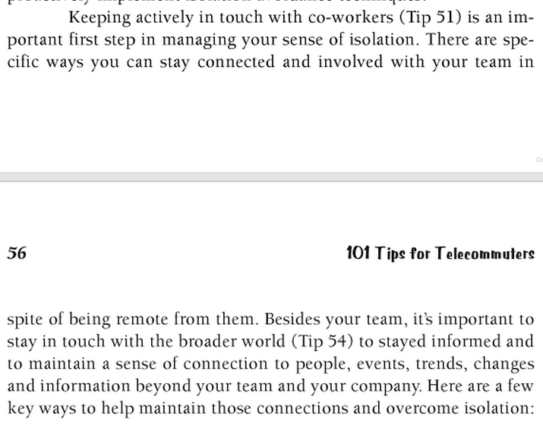
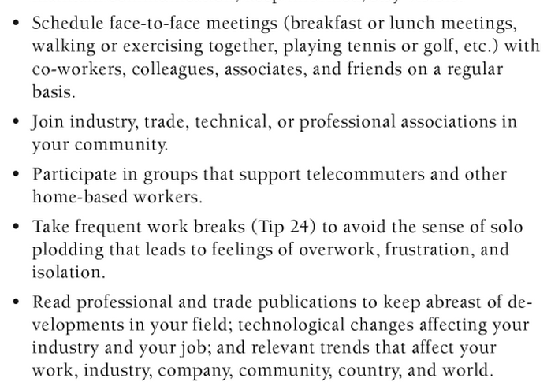
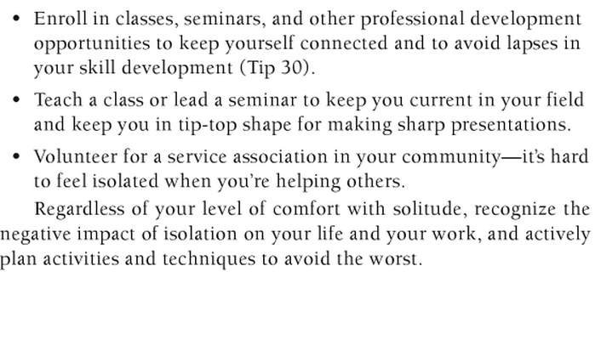

http://hbr.org/1998/05/the-alternative-workplace-changing-where-and-how-people-work/ar/1

Harvard Business Review by Mahlon Apgar – May 1998

14 years ago this article

